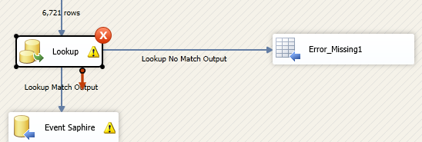

Change Lookup to

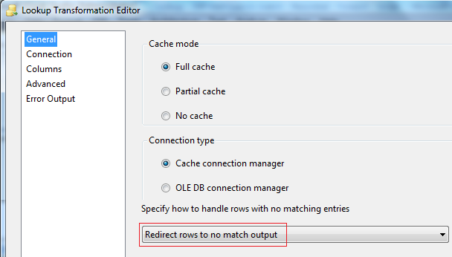

Now, if when running , in the log your received the message

[Lookup [145]] Warning: The Lookup encountered duplicate reference key values when caching reference data. This error occurs in Full Cache mode only. Either remove the duplicate key values, or change the cache mode to **PARTIAL or NO_CACHE.**

Then change from Full cache to Partial cache, and allow duplicates

